What Connectionist Models Can Learn From Music

Piat Frederic
Laboratoire Informatique de Paris 6 (LIP6),
Université Pierre et Marie Curie, Paris
frederic.piat@lip6.fr

ABSTRACT
Whereas many connectionist models have been applied to music, few of them have actually been concerned with a direct comparison with humans: the learning conditions are rarely realistic, and the performance hardly ever compared to that of humans on the same task. However, I show here that the simple neural network ARTIST, not specifically designed for a particular problem and learning unsupervised, can be general enough to emulate very accurately the behaviour of humans on a variety of tasks. These range from the memorisation of a melody to the judgement of its aesthetic qualities, and going through its recognition amongst distractor notes, the development of the sense of inter-key distances through learning, or the representation of tonal relationships. In particular, ARTIST's responses when subject to the probe-tone technique are very similar to that of humans, and show the same evolution as children's responses as both are more and more exposed to music.
Besides making predictions and testing hypotheses for psychological or neurobiological theories, we can imagine many practical applications of the model, like music composition and harmonisation, a tool for assisted composition, a partner for interactive improvisation, and search engines for musical databases taking into account precise user preferences and specifications. Moreover, none of the above is limited to a particular musical style, since the behaviour of the model entirely depends on the musical pieces the user chooses for its learning.

Keywords
Neural networks, cognition, ART, user profile, musical preferences

INTRODUCTION

1.1 Mental Representations
It is often not until we are faced with an unfamiliar musical style that we fully realize the importance of the musical mental schemata gradually acquired through our past listening experience. These cognitive structures automatically intervene as music is heard, and they are necessary to build integrated and organized perceptions from acoustic sensations: without them, as it happens when listening to a piece in a musical style foreign to our experience, a flow of notes seems like a flow of words in a foreign language, incoherent and unintelligible. The impression is that all pieces or phrases sound more or less the same, and musical styles such as Indian Rags, Chinese Guqin or Balinese Gamelan are often qualified as being monotonous by Western listeners, new to these kinds of music. This happens to experienced, musically trained listeners as well as to listeners without any musical experience other than just listening. Thus it is clear that the mental schemata required to interpret a certain kind of music can be acquired through gradual acculturation (Francès, 1988), which is the result of passive listening in the sense that it does not require any conscious effort or attention directed towards learning. This is not to say that formal training has no influence, but only that it is not necessary and that exposure to the music is sufficient.
Becoming familiar with a particular musical style usually implies two things: 1) The memorization of particular melodies 2) An intuitive sense of the prototypicality of musical sequences relative to that style (i.e., the sense of tonality in the context of Western music). These underlie two kinds of expectancies, respectively melodic and stylistic expectancies. Melodic (also called 'veridical') expectancies rely on the listener's familiarity with a particular melody and refer to his knowledge of which notes will be coming next after hearing part of it. Stylistic expectancies rely on the listener's familiarity with a particular musical style, and refer to his sense of the notes that should or will probably follow a passage in order for the piece to fit well in that style. These expectancies can be probed in different ways, for instance with Dowling's (1973) recognition task of familiar melodies interleaved with distractor notes, and Krumhansl and Shepard's (1979) probe-tone technique, respectively.

1.2 Previous Connectionist Models
Some connectionist models of tonality have been proposed before but they are rarely realistic in that they often use a priori knowledge from the musical domain (e.g., octave equivalence) or are built without going through learning (Bharucha, 1987; extended by Laden, 1995). This paper presents an Artificial Neural Network (ANN), based on a simplified version of Grossberg's (1982) Adaptive Resonance Theory (ART) to model the tonal acculturation process. The model does not presuppose any musical knowledge except the categorical perception of pitch for its input, which is a research problem in itself (Sano and Jenkins, 1989) and beyond the scope of this paper. The model gradually develops through unsupervised learning. That is, it does not need any other information than that present in the music to generate the schemata, just like humans do not need a teacher. Gjerdingen (1990) used a similar model for the categorization of musical patterns, but did not aim at checking the cognitive reality of these musical categories. Page (1999) also applied successfully ART2 networks to the perception of musical sequences. The goal of the present paper is to show that this simple and realistic model is cognitively pertinent, by comparing its behaviour with humans' directly on the same tasks. As mentioned in the previous section, these tasks have been chosen because they are robust, having stood the test of time, and because they reflect broad and fundamental aspects of music cognition.

The Neural network model artist

2.1General Principles
I provide here only a general presentation of the model ARTIST (Adaptive Resonance Theory to Internalize the Structure of Tonality), the technical details being outside the scope of this paper. More details can be found in Piat (1999,2000). ARTIST is based on a slightly simplified version of the Adaptive Resonance Theory (ART2) developed by Carpenter and Grossberg (1987). It is a machine learning method for the classification of input patterns, which can be analogue (coded with continuous values, as opposed to binary values). The learning is unsupervised, meaning that it is based solely on the similarity of the inputs and does not depend on any knowledge of music provided to the model by a hypothetical ‘teacher’ or superviser. The model consists of an input layer F1 of formal neurons, linked with connections (equivalent to synaptic weights) of various strengths to a second layer of neurons F2 where the classification takes place. The synaptic weights play the role of both Bottom-Up and Top-Down connections, and they are the long-term memory of the NN, where the description of the categories is stored. The role of the learning algorithm is twofold: First, it creates categories in F2 when needed, that is when an input is sufficiently different from what has been learned so far and does not fit in any existing category; second, it tries to find an optimal set of synaptic weights that progressively tune the 'category units' in F2 to be most responsive to a certain input pattern (the 'prototype' for this category), so that a meaningful categorisation can emerge.

2.2 Input Layer
The music we want to present to the model is coded in F1 (Bottom layer). Each neuron in F1 represents a particular note, and it is activated each time this note is played, proportionally to its loudness. For now the model will be tested only with conventional Western music, so an acoustic resolution of one neuron per semitone is sufficient to code the musical pieces used. This is the only constraint applied to the model imposed by assuming Western music, and this can easily be overridden simply by changing the number of input nodes. Bach's 24 preludes from the Well-tempered clavier were used for learning. The notes they contain span 6 octaves. With 12 notes per octave, 72 nodes are needed to code the inputs. The F1 activations are updated after each measure of the piece: Each note played within the last measure activates its corresponding input neuron proportionally to its loudness (or velocity; notes falling on beats 1 and 3 were accentuated). After this, the activations decay exponentially over time, which allows the model to keep in its inputs a kind of memory of the musical context.

2.3 Category Layer
The role of the neurons in F2 (Top layer, containing the categories) is to represent a category each, and to signal by their activation level whether the input belongs to that category or not. The synaptic weights feeding into a particular F2 neuron store the prototype of its corresponding category. Prototypes are compact representations of all the input patterns similar enough to each other; thus each prototype reflects a category, it is its best representative, and an input pattern that would exactly match that prototype would activate the category to the maximum degree, 100%.

2.4 Propagation of Activation
The functioning of the model is based on a succession of Bottom-Up and Top-Down cycles. When an input is presented in F1, activation spreads to F2 by computing the match between each F2 prototype and the input. The degree of activation (or match) of each category depends on the similarity between its prototype (stored in the weights) and the input. The fuzzy AND operator (i.e., min) is used as the similarity measure. This operator keeps, for each dimension of the vectors, the smallest value of the two vectors. Thus it is equivalent to computing the proportion of features common to both the input and the prototype: The more features in common, the higher the match between the two and the higher the activation for that category.
Then the category with the highest activation is selected as the winner and the other categories' activations reset to zero. The winner then propagates activation back to the F1 layer. This is done through the same synaptic values as for the Bottom-Up activation spread. The Top-Down propagation of activation helps the NN to keep a trace of the musical context, as it has been perceived, and acts as a kind of cognitive filter or attentional focus. Last, this Top-Down activation is averaged by the activations coming from the next bar of music to constitute the new inputs, and the cycle can start again.

2.5 Learning
The role of the learning phase is to build the categories and to update their prototypes. After propagation of Bottom-Up activation, the winning category’s activation is compared to a threshold, called vigilance. An activation value under the threshold means that the input does not fit well into any existing category, and therefore a new category has to be created. The new prototype is set equal to the input pattern, because this is the first and only one input belonging to this new category. On the other hand if the value is above threshold, the input belongs to a category that already exists, and the corresponding prototype is modified to reflect the new input. This is done by a linear combination of the former prototype and of the new input to be included. Thus the vigilance parameter controls the generality of the categories and is therefore crucial in that it determines the final architecture of the NN. With a high vigilance, an input has to be very similar to a prototype to fit in its category, so many narrow categories are created, that contain few exemplars. In the extreme case, with a vigilance equal to 1, one prototype is created for each new input, leading to perfect memorization but poor abstraction. As the vigilance decreases, categories get wider to include more input patterns, and have rather abstract prototypes. In the other extreme case, a vigilance equal to 0 would create only one category that includes all inputs and cannot differentiate anything.
ARTIST was trained with the 24 Bach Preludes. To increase the corpus of examples, each prelude was presented 12 times, transposed in all possible keys, for a total of 288 pieces. ARTIST's behaviour is quite robust regarding the vigilance values, at least when they lie in the middle range. With the chosen value equal to 0.55, the presentation of the 41,004 input measures constituting the 288 pieces resulted in the creation of 709 categories.

Simulating Melodic Expectancies
When we are very familiar with a melody, we can usually still recognize it after various transformations like transposition, rhythmic or tonal variations, etc... This is not the case when distractor (random) notes are added in between the melody notes, and even the most familiar tunes become unrecognizable as long as the distractors 'fit in' (if no primary acoustic cue like frequency range, timbre or loudness for instance segregates them; Bregman, 1990). However, when given a few possibilities regarding the identity of the melody, it can be positively identified (Dowling, 1973). This means that Top-Down knowledge can be used to test hypotheses and categorize stimuli. For melodies, this knowledge takes the form of a pitch-time window within which the next note should occur, and enables the direction of auditory attention (Dowling, Lung & Herrbold, 1987; Dowling, 1990). As the number of possibilities offered to the subject increases, his ability to name that tune decreases: when Top-Down knowledge becomes less focused, categorization gets more difficult. With its built-in mechanism of Top-Down activation propagation, ARTIST can be subjected to the same task.

3.1 Method
To get ARTIST to become very familiar with the first 2 measures of 'Twinkle twinkle little star', the learning rate and vigilance values were set to their maximum (equal to 1 for both), so that the learning procedure would create two new F2 nodes to memorize those two exemplars and act as labels for the tune. Had the vigilance level been too low, the tune would have been assimilated into an already existing category, which activation couldn't be interpreted as recognition of the tune. After learning the tune, the activation in F2 was recorded under 5 conditions corresponding to the presentation of:
  - The original melody alone
  - The melody with distractors,
    - No Top-Down activation
    - Top-Down activation from the label nodes
    - Top-Down activation from the label nodes and 3 others (random)
  - Control condition: A different melody (Prelude #1) with distractors, Top-Down activation from the label nodes
The control condition is necessary to make sure that testing the hypothesis that the tune is 'Twinkle twinkle...' by activating the label nodes does not always provoke false alarms.
For each condition, the activation ranks of the 2 label nodes were computed (1 for the most activated, 2 for the next, and so on) and added. A low rank indicates few categories competing and interfering with the recognition, and a probable "Yes" response to the question "Is this Twinkle twinkle ?". As the sum of the ranks increases, meaning the label nodes are overpowered by other categories, the response goes towards "No".

3.2 Results
Results appear in Figure 1. Thus the straight presentation of the tune results in the smallest possible summed ranks, equal to 3: ARTIST recognizes unambiguously the melody. When the melody is presented with distractors, the ranks are higher, indicating some difficulty in recognition. Among these 3 conditions, the lowest ranks are found when testing the 'Twinkle' hypothesis and only that one. The label nodes are amongst the top 5 most activated, which suggests a strong possibility to identify the melody. Then, identification gets much more difficult when testing multiple hypotheses, about as difficult as without Top-Down activation (no explicit hypothesis is being tested), exactly like when human subjects are not given a clue about the possible identity of the melody. Finally, the control condition shows that ARTIST does not imagine recognizing the melody amongst distractors when it is not there, even after priming the activation of its notes through Top-Down propagation.
Equivalent results can be obtained by summing the activations of the label nodes instead of computing their ranks. However, given the important number of categories, small differences of activation (especially in the middle range) imply strong differences in ranks, and therefore the latter measure was preferred to exhibit the contrast between conditions. In any case, the order of the conditions most likely to lead to the recognition of the familiar melody is the same for ARTIST and humans, and the effects of melodic expectancies can easily be observed in ARTIST.

Predicting Aesthetic Judgement
After the learning phase that built ARTIST, I tested whether it had acquired any knowledge of music, and more particularly of tonality, by merely learning to categorize musical bars. The most general and concise characterization of tonality --and therefore of most Western music-- probably comes from the work of Krumhansl (1990). With the probe-tone technique, she empirically quantified the relative importance of pitches within the context of any major or minor key, by what is known as the 'tonal hierarchies'. These findings are closely related to just about any aspect of tonality and of pitch use: frequency of occurrence, accumulated durations, aesthetic judgements of all sorts (e.g., pitch occurrence, chord changes or harmonization), chord substitutions, resolutions, etc... Many studies support the cognitive reality of the tonal hierarchies (Jarvinen, 1995; Cuddy, 1993; Repp, 1996; Sloboda, 1985; Janata and Reisberg, 1988). All these suggest that subjecting ARTIST to the probe-tone technique and comparing the results to Krumhansl’s reference tone profiles is a good way to test whether it has extracted a notion of tonality (or its usage rules) from the music it was exposed to, or at least elements that enable a reconstruction of what tonality is.

4.1 Method
The principle of the probe-tone technique is quite simple. A prototypical sequence of chords or notes is used as musical context, to establish a sense of key. The context is followed by a note, the probe tone, that the subjects have to rate on a scale to reflect how well the tone fits within this context, to which extent it completes the context in an aesthetic way. Repeating this procedure for all 12 possible probe notes of the chromatic scale, the tone profile of the given key can be generated. Out of the many types of contexts used by Krumhansl et al. over several experiments, the 3 standard ones were retained to test ARTIST: for each key and mode (major and minor), the corresponding chord, the ascending and the descending scales were used as contexts. Several keys are used so the results do not depend on the choice of the particular pitch of reference. Here all 12 keys are used (as opposed to 4 by Krumhansl) and ARTIST's profile is obtained by averaging the profiles obtained with the 3 contexts for each key, after transposition to a common tonic. Thus the tone profile obtained for each mode is the result of 432 trials (3 contexts × 12 keys × 12 probes). After each trial, the activations of the F2 nodes were recorded. Following Katz' (1999) idea that network's total activation directly relates to pleasantness, the sum of all activations in F2 is taken as ARTIST's response to the stimulus, the index of its receptiveness/aesthetic judgement towards the musical sequence. It seems logical that what is familiar to the model elicits the strongest response over the whole field F2, and that the sum of activations in F2 was the correct measure. However it turned out that the most familiar, prototypical stimuli highly activate very few categories whereas the remaining ones have very low activations. On the other hand, if ambiguous stimuli do not strongly activate any category, they mildly activate many of them. Given their important number, this results in a low overall F2 activation for inputs similar to those learnt, and in high activations for unfamiliar input patterns. Therefore the opposite of the sum of all activations in F2 was taken as an index of ARTIST’s response.
A last detail was considered in order to carry out human and computer tests in similar conditions. It appeared in the first studies using the probe-tone technique that subjects judged the fitness of the probe-tone more as a function of its acoustic frequency distance from the last note played rather than as a function of tonal salience. This results naturally from the usual structure of melodies, that favours small steps between consecutive notes. This problem was eluded by using Shepard tones (Shepard, 1964). They are designed to conserve the pitch identity of a tone while removing the cues pertaining to its height, and their use to generate ever-ascending scales illusions prove they indeed possess this property. Shepard tones are produced by generating all the harmonics of a note, filtered through a bell-shaped amplitude envelope. To simulate Shepard tones for ARTIST, the notes are played simultaneously on all 6 octaves, with different velocities (loudness) according to the amplitude filter: high velocities for the middle octaves, decreasing as the notes get close to the boundaries of the frequency range.

4.2 Results
Figures 2 and 3 allow direct comparison of the tone profiles obtained with human data (Krumhansl and Kessler, 1982) and with ARTIST, for major and minor keys, respectively. Both Pearson correlation coefficients between human and ARTIST profiles are significant, respectively -.95 and -.91, p<.01 (2-tail). Surprisingly, but for the reasons explained above, the correlations are negative, so ARTIST's profiles are inverted on the figures for easier comparison with the human data.
Once the tone profile for a particular key is available, we can deduce the profiles of all other keys by transposition. Then, we can compute the correlation between two different key profiles as a measure of the distance between the two keys. This is the procedure used by Krumhansl to obtain all the inter-key distances, and the same was done with ARTIST data, to check whether its notion of key distances conforms that of humans. Both graphs for distances between C major and all minor keys are shown in Figure 4. Keys on the X-axis appear in the same order as around the circle of fifths. It is immediately apparent that both profiles are close to being identical. This is even more true for the key distances between C major and all major keys, as well as for distances between C minor and all minor keys: The correlations between human and ARTIST data for major-major, minor-minor and major-minor key distances are respectively .988, .974 and .972, all significant at p<.01.
Thus ARTIST clearly emulates human responses on the probe-tone task, and therefore can be said to have developed a notion of tonality, with the tonal invariants extracted directly from the musical environment. This shows that ARTIST has internalised in its structure the rules of tonality, leading to a behaviour virtually identical to humans when it comes to the sense of aesthetic judgement of a musical sequence.

UNDERSTANDING ARTIST
The great advantage of NN compared to more traditional artificial intelligence approaches is their ability to learn. Some NN models have been built without learning like Bharucha’s MUSACT (1987), where the synaptic weights were set ‘by hand’ according to previous knowledge of music theory and of music symbols manipulation. If these examples are rare in the NN litterature, their advantage is that their structure and their functioning are straightforward to understand, because the symbolic meaning of the neurons and connections is already known. On the other side, NN obtained by learning can discover relationships between inputs or between input and output that we would not suspect before hand, but they usually work at a subsymbolic level. That is, their final structure is so complex that understanding the role of a particular synaptic weight or neuron is very difficult: each of them brings an infinitesimal participation to the computations, which makes impossible the understanding of the function of one element independently from the others. However, this is not the case for ARTIST. Even though the visualisation of the 72 x 709 synaptic weights matrix yields a confusing plot, collapsing the 72 inputs across octaves on only 12 notes groups the neurons and their weights by tonal function, and the internal organisation of ARTIST becomes clear. The 12 x 709 resulting synaptic matrix is shown in Figure 5, with prototypes (columns) sorted by decreasing order of correlation with the reference profile.
We can recognise on this plot a 3-D extension of the 2-D plots of the tone profiles in Figure 2. In the latter, the highest peaks in decreasing order are for pitches C (the tonic), G (the fifth), E (the major third), F (the fourth), and so on… The peaks are in the same order in the plot of synaptic weights as we move from the foreground to the background, to end with the 5 peaks corresponding to the 5 chromatic pitches of the C major scale.
The fact that the visualisation of the connexions can be organised in such a way to enable understanding of how the model works has strong implications. This enables us to manipulate it easily and to use it to develop applications. For instance this can guide us to find a way to code the music in symbolic terms related to tonality, independently from the surface details. This code can relate to key modulations, the evolution of tonal tension within the piece, mode changes, resolutions, etc… In other words, anything relating to the tonal features themselves.

Figure 5: ARTIST’s “synaptic landscape”.
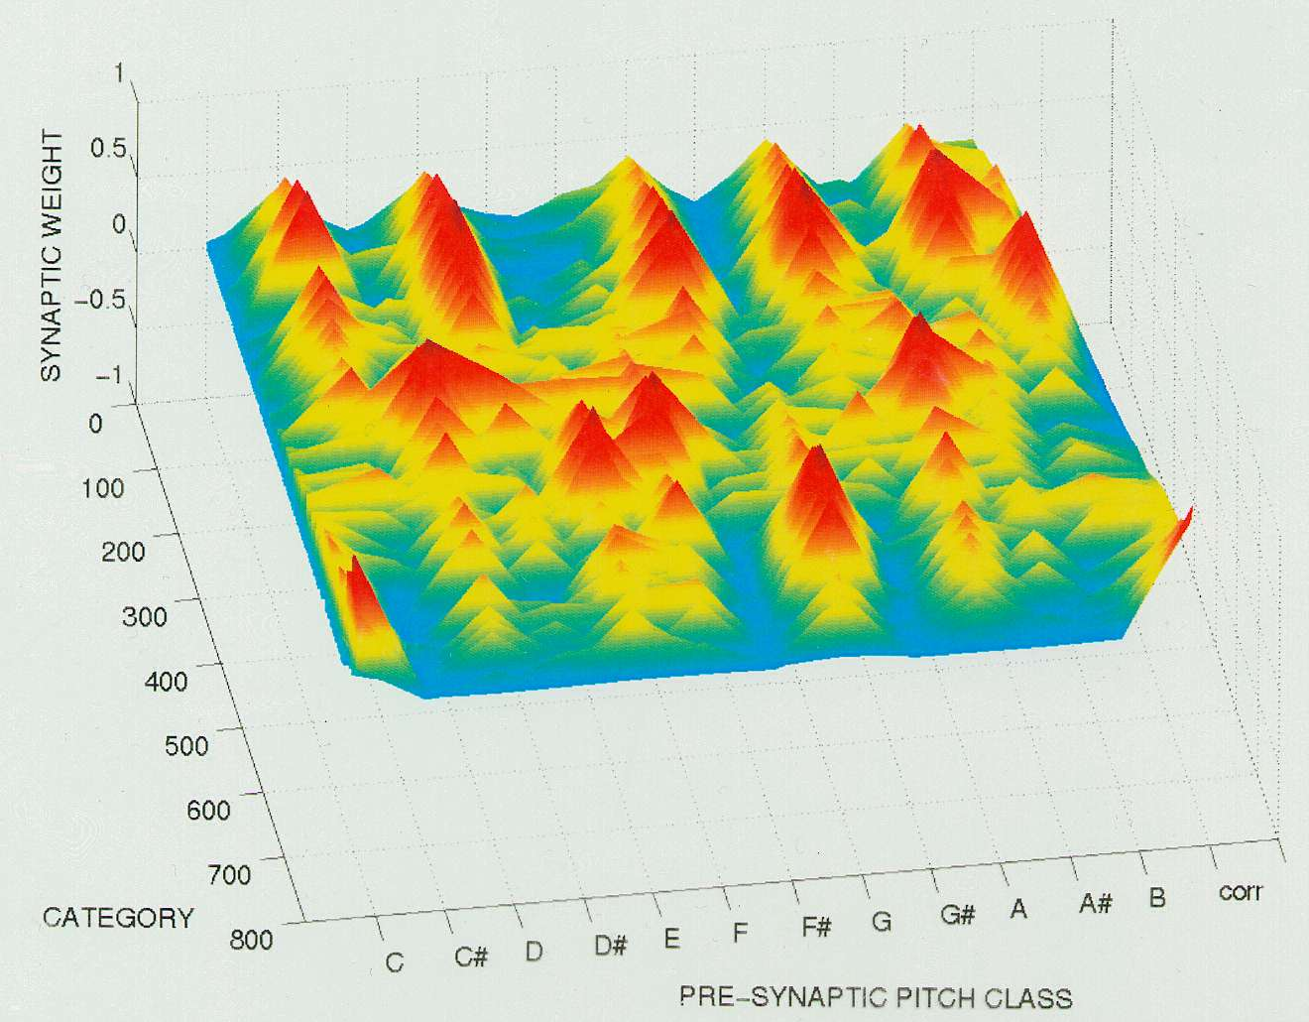
More precisely, this code can be seen as a mapping of the inputs, the music, onto the F2 categories or their corresponding connexions. Once we know how to map the unfolding music onto this “synaptic landscape”, observing the path described by the music can tell us right away many things about the music: coherent music moves smoothly from one peak to a neighbouring peak, whereas when the path goes back and forth between the foreground and background it means the modulations are in distant keys and the music is perceived as incoherent. We can immediately see the subtleness of the modulations, whether they go to close or distant keys, as well as their directions, the frequency of return to the original key, and so on…By mapping several songs onto the same landscape, we can compute their similarity or look for specific features they have in common. Note that all the above is relative to the musical experience of the model, which is under total control of the user. Another possibility would be to compare directly the 2 landscapes generated by 2 songs or sets of songs. However, unlike the first approach mentioned above, this method would probably lose a lot of the temporal information that might be crucial to the particular feeling generated by a piece.

POTENTIAL APPLICATIONS TO THE WWW
With the emergence of convenient standards and formats for music storage (like MP3) and large bandwidth communications (like UMTS), the world of music distribution is moving fast from hardware supports towards software supports. On the long-term, this mutation means that CD supports and the like will probably be replaced by all-streaming or downloading solutions, with access to databases containing thousands of songs on a pay-for-membership basis. Helping the user find its way through these rich databases is a major challenge. Moreover, the World Wide Web (WWW) community aims at offering increasingly personalised services, customised to each user’s preferences and needs, in order to maximize customer satisfaction and fidelity. Another consequence of this mutation is the possibility to exploit the interactivity of the WWW with the user to provide new kinds of services, for instance relating to the editing of the distributed music itself.
In this context, obtaining a profile of the musical preferences of a user as accurate as possible is of real value. Up to now, the techniques used to this end have been quite rudimentary. They rely on personal data such as which artists the user listens to, and the musical category they belong to. This data is then used in a straightforward way to infer which music the user will likely be interested in: other songs of the same artists, of other artists closely related (sharing band members, influencing or influenced by, similarity according to one or several people…), or anything in the same musical category. This compartmental approach is problematic: if some musical categories are quite homogeneous, others are very vast, and the boundaries between them are rarely clear. For instance, who fits in the category ‘Rock’? Or worst, in the category ‘Pop/Rock’? Or rather, which modern artists do not fit in? Reciprocally, a particular artist may not fall clearly into one style, especially after producing music for several decades and always evolving with the latest trends. Restricting the interest only to associated artists rather than a whole category does not necessarily lead to more exploitable results: one of the leading on-line music store lists for the Beatles 76 similar artists and 577 influenced artists!
Another way to infer people’s taste from their data, and also commonly found in on-line CD stores, is to propose recommendations based on the statistics of what “People who bought this CD also bought…”. While this is more innovative and actually enables some genre-crossing inferences, the result may be sometimes pertinent but not always: there are strong effects of recent popularity, and the albums sold by millions will be in everybody’s list, regardless of the original interest. For instance, the same on-line store as mentioned above tells us that people who bought Jimmy Hendrix’ music also bought Mariah Carey’s! And so did people who bought Andreas Vollenweider’s (Harpist, New Age style), along with as diverse artists as Pearl Jam, Michael Franks, Elton John, Johannes Brahms and music from the movie ‘Titanic’!
Thus we clearly see there is a need to establish finer user profiles, to enable more relevant musical tastes inference methods that will be able to: 1) transcend the rigidity of classification into musical categories, 2) avoid irrelevant associations, and 3) sort the relevant associations by likelihood of interest.
This leads to the idea of establishing a user profile based on the songs he prefers, instead of being based on the preferred artists. In the extreme case, all the songs of a particular artist can be chosen as part of the favourite songs. Ideally, knowing which are the intrinsic qualities of the music the user responds to would be the best start to build the profile, which would then be independent of the classification of music into categories and of all links between artists established subjectively. To summarize, what we need is a model able to predict the aesthetic judgements of a user (which songs he will like, and to which degree), based on the music we already know he likes. The model ARTIST presented above should be able to do just that, since it can predict aesthetic judgements based on its musical environment, which is totally under control of the user. Below are detailed two possible applications of ARTIST.

Music Search
Having a symbolic-based measure of similarity between songs, or of conformity of a song to a certain profile (synaptic landscape), opens many options regarding music search engines. It enables us to compute to which degree a song fits the criteria specified by the user, which can be defined in many different ways. This is where a WWW-based implementation would offer its greatest advantage, by providing access to extensive databases of songs. For instance, the musical inputs used to generate the profile after learning can be:
- All the songs the user has been listening to lately,
- A subset of these, hand-picked by the user or for which he has given feed-back that he likes, with the possibility to restrict to small passages,
- A set of songs chosen by the user, explicitly or implicitly by a choice of characteristics or labels that can be as different as “Classical”, “Classic Rock”, “Sad”, “Relaxed”, “dissonant”, “atonal”, “modal”, “polytonal”, “Beatles-like”, “with rapid changes of mood”, etc…
For the latter option, it is necessary to pre-define the correspondence between a label and a list of songs representative of its characteristic. The user can choose any number of labels and even give them different weights according to the importance he wants to give to a certain characteristic vs. another. When several labels are chosen simultaneously, the song lists are merged to constitute the musical corpus used for learning. Giving them weights affects the number of times the song is presented to the NN for learning. The generalisation capacity of NN means that we do not need a music specialist to rate all the songs on all the criteria. Just like the 24 Bach Preludes were sufficient to retrieve and internalise the rules of tonality, making a list of a few songs to learn should be sufficient for the model to build a prototypical knowledge of their common quality. However, in order to learn to recognize a new quality, the song list has to be representative of it.

Composition and Improvisation
Another straightforward way to exploit ARTIST’s sense of aesthetics is to make it create music, since it is supposed to know exactly how good a note will sound after a given context. To get such a prediction, we have to use the same procedure as for the probe-tone technique: play the note we want to test, then measure the overall F2 activation. The lower the activation, the better the note fits in the context. We can repeat this operation for all the notes in order to obtain an array of activations. Then, depending on the task we want the model to perform, we can use this array in different ways. As a tool for assisted composition, it can list the notes, chords and/or harmonisations in a decreasing order of goodness. As a generator of alternative versions around a main theme, we can set parameters to indicate how close to the original theme we want the new version to be, that will determine the proportion of notes substituted, and how far can the substitutions go in terms of tonality. At one extreme, the original theme would remain unchanged, whereas at the other extreme it would be random. In between are the versions more or less recognisable, just like when some good Jazzman teases the audience with a piece that sounds familiar but that we cannot identify until he gets close enough to the original theme. The same method can be used for an interactive improvisation system, as it is often the case with musicians that interactive improvisation starts from a common theme and evolves from there, or that the ‘duel’ is based on repeating the partner’s phrase with added embellishments or variations, tonal, rhythmic or otherwise.
For all these possible uses mentioned, the output of the model can be constrained to fit a particular scale or chord progression (or to be more likely to fit it, by using a kind of transfer function shaped as the corresponding tone-profile), which can be useful when the model is used as a help for teaching or rehearsing. But the most important for a successful musical creation is probably the strategy used to choose the note(s) from the array of activation, that is, to transform these activations into an array of probabilities (It is possible to make the system deterministic, but that is certainly the best recipe to create the most boring composer). The computations used for Boltzmann machines, the normalisation used in Hidden Markov Models or the Gibbs-Sampler algorithm, to name a few, will probably yield interesting and inspired automatic compositions.

conclusion
I have shown that after being exposed to a few pieces of music and deriving prototypes from them through learning, the NN ARTIST develops a structure that captures the rules of tonality. From the two simulations we can see that it is easy to subject ARTIST to the same musical tasks as given to humans in a natural way, and that it approximates human behaviour very closely on these tasks. When probed with the standard techniques, it shows both melodic and stylistic expectancies, the two main aspects of musical acculturation. ARTIST learns unsupervised, and its knowledge is acquired only from exposure to music, so it is a realistic model explaining how musical mental schemata can be formed. The implication is that all is needed to accomplish those complex musical processings and to develop mental schemata is a memory system capable of storing information according to similarity and abstracting prototypes from similar inputs, while constantly interpreting the inputs through the filter of Top-Down (already acquired) knowledge. From the common action of the mental schemata results a musical processing sensitive to tonality. This property emerges from the internal organisation of the neural network, it is distributed over its whole architecture. Thus it can be said that the structure of tonality has been internalized. Testing ARTIST with other musical styles could further establish it as a general model of music perception. The major limitation of ARTIST in its current state is that it cannot account for transpositional invariance. Whether the perception of invariance under transposition can be acquired at all through learning is not obvious, as the question concerning how humans possess this ability is still opened.
So, ARTIST is able to predict with a very good precision the human judgements of the aesthetic of a short musical sequence, and this judgement is solely based on ARTIST’s experience with music. Since the user has complete control over its musical universe, ARTIST can be used to extract prototypes from his favorite music. From this customised profile, ARTIST should be able to find the songs that the user will like best, or even compose some songs. Furthermore, this can be done independently from the usual musical styles classification, because what has been learnt essentially relates to the deeper musical properties linked to tonality and transcends the surface details. However, before such applications are operational, more research is needed to be sure that ARTIST can go from the small-scale problems it has been shown to solve, to the full size problems evoked above. In particular, it remains to be seen whether it will work as well with complete music pieces as it does with 10-notes sequences. Also, it is possible that feeding radically different musical styles to the NN for learning may produce unexpected results because of some interference. But there seems no reason for this to happen as long as all is tonal music, and I have good hope that ARTIST would yield meaningful results even in the case of atonal or polytonal music. However, simulations need to be done to know if the internalisation of these different musical styles can be merged into a single model or if several models need to run in parallel and merge their results. Finally, the model will need some optimisation before it can be used for the WWW, to minimise all computations. The optimal vigilance/number of categories will certainly depend on the task to be achieved. But there are good reasons to hope that one day each of us can have his own custom radio that only plays what we like and does not leave out new and emerging musical styles.
REFERENCES
Bharucha, J.J. (1987). Music cognition and perceptual facilitation: A connectionist framework. Music Perception, 5(1), 1-30.
Bregman, A.S. (1990). Auditory scene analysis. Cambridge, MA: MIT Press.
Carpenter, G.A., & Grossberg (1987). ART2: Self-organization of stable category recognition codes for analog input patterns. Applied optics, 26, 4919-4930.
Cuddy, L.L. (1993). Melody comprehension and tonal structure. In T.J.Tighe & W.J.Dowling (Eds.), Psychology and music: the understanding of melody and rhythm. Hillsdale, NJ: Erlbraum.
Dowling, W.J. (1973). The perception of interleaved melodies. Cognitive psychology, 5, 322-337.
Dowling, W.J. (1990). Expectancy and attention in melody perception. Psychomusicology, 9(2), 148-160.
Dowling W.J., Lung, K.M.T., & Herrbold, S. (1987). Aiming attention in pitch and time in the perception of interleaved melodies. Perception and Psychophysics, 41, 642-656.
Francès, R. (1988). La perception de la musique. Hillsdale, NJ: Erlbraum. Originally published 1954. Librairie philosophique J. Vrin, Paris. (Translated by W.J.Dowling)
Gjerdingen, R.O. (1990). Categorization of musical patterns by self-organizing neuronlike networks. Music Perception, 7, 339-370.
Grossberg, S. (1982). Studies of mind and brain: Neural principles of learning, perception, development, cognition and motor control. Boston:D.Reidel/Kluwer.
Janata, P., & Reisberg, D. (1988). Response-time measures as a means of exploring tonal hierarchies. Music Perception, 6(2), 161-172.
Jarvinen, T. (1995). Tonal hierarchies in Jazz improvisation. Music Perception, 12(4), 415-437.
Katz, B.F. (1999). An ear for melody. In Griffith, N. & Todd, P. (Eds.) Musical Networks: Parallel Distributed Perception & Performance, Cambridge: MA, MIT Press. pp 199-224.
Krumhansl, C.L. (1990). The cognitive foundations of musical pitch. Oxford psychology series, No. 17.
Krumhansl, C.L., & Kessler, E.J. (1982). Tracing the dynamic changes in perceived tonal organization in a spatial representation of musical keys. Psychological Review, 89, 334-368.
Krumhansl, C., & Shepard, R. (1979). Quantification of the hierarchy of tonal functions within a diatonic context. Journal of Experimental Psychology: Human Perception and Performance, 5, 579-594.
Laden, B. (1995). Modeling cognition of tonal music. Psychomusicology, 14, 154-172.
Page, M.P.A. (1999). Modelling the perception of musical sequences with self-organizing neural networks. In Griffith, N. & Todd, P. (Eds.) Musical Networks: Parallel Distributed Perception & Performance, Cambridge: MA, MIT Press. pp 175-198.
Piat, F. (1999) ARTIST: Adaptive Resonance Theory for the Internalization of the Structure of Tonality (a neural net listening to music). Doctoral dissertation. http://www-poleia.lip6.fr/~piat/
Piat, F. (2000) ARTIST: A connectionist model of musical acculturation. In Proc. 6th International Conference on Music Perception and Cognition (ICMPC), (August 5-10, 2000), Keele University, UK.
http://www-poleia.lip6.fr/~piat/papers/ARTIST/Artist.html
Repp, B.H. (1996). The Art of inaccuracy: Why pianists' errors are difficult to hear. Music Perception, 14(2), 161-184.
Sano, H, & Jenkins, B.K. (1989). A neural network model for pitch perception. Computer Music Journal, 13(3).
Shepard, R.N. (1964). Circularity in judgments of relative pitch. The journal of the Acoustical Society of America, 36, 2346-53.
Sloboda, J.A. (1985). The musical mind. Oxford psychology series, No.5. Bharucha, J.J. Music cognition and perceptual facilitation: A connectionist framework. Music Perception 5 ,1 (1987), 1-30.

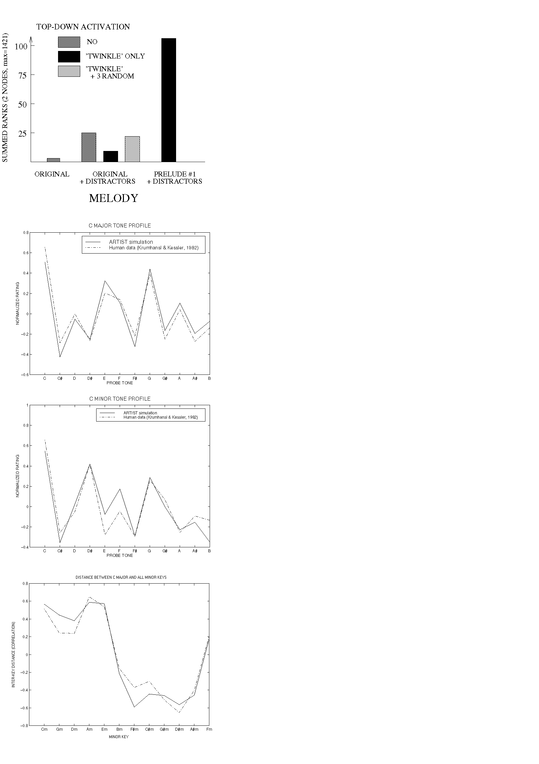
From top to bottom:
Figure 1. Summed ranks of the 2 label nodes for 'Twinkle twinkle' as a function of stimulus played and hypothesis tested.
Figure 2. Comparison of ARTIST and Krumhansl & Kessler (1982) C major tone profile (correlation = .95).
Figure 3. Comparison of ARTIST and Krumhansl & Kessler (1982) C major tone profile (correlation = .91).
Figure 4. Comparison of ARTIST and Krumhansl & Kessler (1982) inter-key distances between C major and all minor keys (correlation = .972).

