The Neural Network Model of Music Cognition ARTIST and Applications to the WWW

Piat Frederic
Image Video and Multimedia Systems Laboratory,
Dept. of Electrical and Computer Engineering,
National Technical University of Athens,
Zografou 15773, Greece
(+301) 772-2521
piat@image.ntua.gr

ABSTRACT
We present here a simple ART2 Neural Network (NN) model, ARTIST, and show how after simple exposure to music and unsupervised learning, it is able to simulate high level perceptual and human cognitive abilities. Amongst other things, it is able to predict with a very high degree of accuracy how good a short musical sequence will sound to human ears. For this, ARTIST has to be exposed to the same kind of music as the listeners’. Such a model able to recover the rules of music aesthetics according to a particular musical environment, totally under control of the user, can have many applications to the distribution of music through the World Wide Web. The most straightforward application is to build an accurate profile of the user’s musical preferences, based on the musical content itself. This should avoid the usual drawbacks of the current search engines and other “musical advisors”, which base their advices on rigid musical style classifications, too general and unpersonal. Other applications can range from assisted composition to interactive man-machine duet improvisation or the creation of on-line alternative versions of songs (remix).

Keywords
Neural networks, cognition, ART, user profile, musical preferences

INTRODUCTION
With the emergence of convenient standards and formats for music storage (like MP3) and large bandwidth communications (like UMTS), the world of music distribution is moving fast from hardware supports towards software supports. On the long-term, this mutation means that CD supports and the like will probably be replaced by all-streaming or downloading solutions, with access to databases containing thousands of songs on a pay-for-membership basis. Helping the user find its way through these rich databases is a major challenge. Moreover, the World Wide Web (WWW) community aims at offering increasingly personalised services, customised to each user’s preferences and needs, in order to maximize customer satisfaction and fidelity. Another consequence of this mutation is the possibility to exploit the interactivity of the WWW with the user to provide new kinds of services, for instance relating to the editing of the distributed music itself.

.

In this context, obtaining a profile of the musical preferences of a user as accurate as possible is of real value. Up to now, the techniques used to this end have been quite rudimentary. They rely on personal data such as which artists the user listens to, and the musical category they belong to. This data is then used in a straightforward way to infer which music the user will likely be interested in: other songs of the same artists, of other artists closely related (sharing band members, influencing or influenced by, similarity according to one or several people…), or anything in the same musical category. This compartmental approach is problematic: if some musical categories are quite homogeneous, others are very vast, and the boundaries between them is rarely clear. For instance, who fits in the category ‘Rock’? Or worst, in the category ‘Pop/Rock’? Or rather, which modern artists do not fit in? Reciprocally, a particular artist may not fall clearly into one style, especially after producing music for several decades and always evolving with the latest trends. Restricting the interest only to associated artists rather than a whole category does not necessarily lead to more exploitable results: one of the leading on-line music store lists for the Beatles 76 similar artists and 577 influenced artists!
Another way to infer people’s taste from their data, and also commonly found in on-line CD stores, is to propose recommandations based on the statistics of what “People who bought this CD also bought…”. While this is more innovative and actually enables some genre-crossing inferences, the result may be sometimes pertinent but not always: there are strong effects of recent popularity, and the albums sold by millions will be in everybody’s list, regardless of the original interest. For instance, the same on-line store as mentioned above tells us that people who bought Jimmy Hendrix’ music also bought Mariah Carey’s! And so did people who bought Andreas Vollenweider’s (Harpist, New Age style), along with as diverse artists as Pearl Jam, Michael Franks, Elton John, Johannes Brahms and music from the movie ‘Titanic’!
Thus we clearly see there is a need to establish finer user profiles, to enable more relevant musical tastes inference methods that will be able to: 1) transcend the rigidity of classification into musical categories, 2) avoid irrelevant associations, and 3) sort the relevant associations by likelihood of interest.
This leads to the idea of establishing a user profile based on the songs he prefers, instead of being based on the preferred artists. In the extreme case, all the songs of a particular artist can be chosen as part of the favorite songs. Ideally, knowing which are the intrinsic qualities of the music the user respons to would be the best start to build the profile, which would then be independent of the classification of music into categories and of all links between artists established subjectively. To summarize, what we need is a model able to predict the aesthetic judgements of a user (which songs he will like, and to which degree), based on the music we already know he likes. We present below ARTIST, a Neural Network (NN) model that does just this. After explaining how it derives a sense of aesthetics very similar to that of humans from a list of songs, we discuss the contributions of the model and its possible applications to the WWW.

The Neural network model artist

General Principles
We provide here only a general presentation of the model ARTIST (Adaptive Resonance Theory to Internalize the Structure of Tonality), the technical details being outside the scope of this paper. More details can be found in Piat [5,6]. ARTIST is based on a slightly simplified version of the Adaptive Resonance Theory (ART2) developed by Carpenter and Grossberg [2]. It is a machine learning method for the classification of input patterns, which can be analogue (coded with continuous values, as opposed to binary values). The learning is unsupervised, meaning that it is based solely on the similarity of the inputs and does not depend on any knowledge of music provided to the model by a hypothetical ‘teacher’ or superviser. The model consists of an input layer F1 of formal neurons, linked with connections (equivalent to synaptic weights) of various strengths to a second layer of neurons F2 where the classification takes place. The role of the learning algorithm is to create categories in F2 when it is needed --when an input is sufficiently different from what has been learned so far and does not fit in any exististing category-- and to find an optimal set of synaptic weights for a meaningful categorisation to occur. These connections are the long-term memory of the NN, where the description of the categories is stored.

Propagation of Activation
The music we want to present to the model is coded in F1 (Bottom layer). Each neuron in F1 represents a particular note, and it is activated each time this note is played, proportionally to its loudness. We assume here that there are 12 notes to an octave, as is the case for the vast majority of music found around the world. The F1 activations are updated after each measure of the piece. After this, the activations decay exponentially over time, which allows the model to keep in its inputs a kind of memory of the musical context. The role of the neurons in F2 (Top layer, containing the categories) is to signal by their activation level whether the input belongs to the category or not. The synaptic weights feeding into a particular F2 neuron store the prototype of its corresponding category. Prototypes are compact representations of all the input patterns similar enough to each other; thus each prototype reflects a category, it is its best representative, and an input pattern that would exactly match that prototype would activate the category to the maximum degree, 100%.
The functioning of the model is based on a succession of Bottom-Up and Top-Down cycles. When an input is presented in F1, activation spreads to F2 by computing the match between each F2 prototype and the input. Then the category with the highest activation is selected as the winner and propagates activation back to the F1 layer. This is done through the same synaptic values as for the Bottom-Up activation spread. The Top-Down propagation of activation helps the NN to keep a trace of the musical context, as it has been perceived, and acts as a kind of cognitive filter or attentional focus. Last, this Top-Down activation is averaged by the activations coming from the next bar of music to constitute the new inputs, and the cycle can start again.
The match between an input pattern and a prototype, their similarity, is computed with the fuzzy AND (i.e., min) operator. This operator keeps, for each dimension of the vectors, the smallest value of the two vectors. Thus it is equivalent to the computation of features common to both vectors, the input and the prototype. The more features in common, the higher the match between the two and the higher the activation for that category.

Learning
The role of the learning phase is to build the categories or to update their prototypes. After propagation of Bottom-Up activation, the winning category’s activation is compared to a threshold, called vigilance. An activation value under the threshold means that the input does not fit well into any existing category, and therefore a new category has to be created. The new prototype is set equal to the input pattern, because this is the first and only one input belonging to this new category. On the other hand if the value is above threshold, the input belongs to a category that already exists, and the corresponding prototype is altered to include in its representation the latest input. This is done by a linear combination of the former prototype and of the new input to be included. Thus the vigilance parameter is crucial in that it determines the final architecture of the NN. With a high vigilance, an input has to be very similar to a prototype to fit in its category, so many narrow categories are created. In the extreme case, with a vigilance equal to 1, one prototype is created for each new input. As the vigilance decreases, categories get wider to include more input patterns. In the other extreme case, a vigilance equal to 0 would create only one category that includes all inputs and cannot differentiate anything.
ARTIST was trained with the 24 Bach Preludes. These span 6 octaves, so F1 contains 72 input neurons. To increase the corpus of examples, each prelude was presented 12 times, transposed in all possible keys, for a total of 288 pieces. The training phase, with a vigilance value in the middle-range (equal to 0.55) resulted in the creation of 709 categories.

Predicting Aesthetic Judgement
After the learning phase that built ARTIST, we tested whether it had acquired any knowledge of music, and more particularly of tonality, by merely learning to categorize musical bars. The most widely used and accepted way of assessing the tonal strength of a musical sequence is to use the probe-tone technique, developed by Krumhansl and Shepard [5]. This is used to obtain a tonal profile of the excerpt, that can be compared to the tone profiles of reference summarised in Krumhansl [3]. This comparison reveals to which degree the excerpt conforms to the rules of tonality, whether it is strongly tonal or not. The principle of the probe tone technique is to play a musical context, followed by one note, the probe tone. Listeners are then asked to rate on a scale how well this probe tone fits into the context, to which extent it completes the context in an aesthetic way. Using all 12 notes from the chromatic scale on successive trials yields a tone profile. To obtain the reference profiles, Krumhansl and Kessler [4] used several different contexts, but all strongly prototypical of a key and mode. For instance, the C Major tone profile is the average of the profiles obtained by musical contexts such as the ascending major scale, the descending major scale and the C major chord. The same procedure was used to obtain the C minor tone profile except that minor scales and chords were used for the contexts. By transposition, the tone profiles of any major or minor key can be obtained.
The same task was given to ARTIST: all 3 contexts were used in all 12 keys for each of the 12 probe tones, resulting in 432 trials for each mode. To measure ARTIST’s response, we started from the hypothesis that what is familiar to the model elicits the strongest response over the whole field F2, so the sum of activations in F2 was measured. However it turned out that the most familiar, prototypical stimuli highly activate very few categories whereas the remaining ones have very low activations. On the other hand, if ambiguous stimuli do not strongly activate any category, they mildly activate many of them. Given their important number, this results in a low overall F2 activation for inputs similar to those learnt, and in high activations for unfamiliar input patterns. Therefore the opposite of the sum of all activations in F2 was taken as an index of ARTIST’s response.
The results from the 12 keys were transposed to a common tonic to obtain ARTIST’s tone profiles. Figure 1 shows the comparison between the original human tone profiles and ARTIST’s, for both major and minor modes. We can observe that they are almost identical, and the Pearson correlation coefficients between profiles are both significant, respectively .95 and .91, p<.01 (2-tail). This clearly shows that ARTIST has internalised in its structure the rules of tonality, leading to a behaviour virtually identical to humans when it comes to the sense of aesthetic judgement of a musical sequence.

UNDERSTANDING ARTIST
The great advantage of NN compared to more traditional artificial intelligence approaches is their ability to learn. Some NN models have been built without learning like Bharucha’s MUSACT [1], where the synaptic weights were set ‘by hand’ according to previous knowledge of music theory and of music symbols manipulation. If these examples are rare in the NN litterature, their advantage is that their structure and their functioning are straightforward to understand, because the symbolic meaning of the neurons and connections is already known. On the other side, NN obtained by learning can discover relationships between inputs or between input and output that we would not suspect before hand, but they usually work at a subsymbolic level. That is, their final structure is so complex that understanding the role of a particular synaptic weight or neuron is very difficult: each of them brings an infinitesimal participation to the computations, which makes impossible the understanding of the function of one element independently from the others. However, this is not the case for ARTIST. Even though the visualisation of the 72 x 709 synaptic weights matrix yields a confusing plot, collapsing the 72 inputs across octaves on only 12 notes groups the neurons and their weights by tonal function, and the internal organisation of ARTIST becomes clear. The 12 x 709 resulting synaptic matrix is shown in Figure 2, with prototypes (columns) sorted by decreasing order of correlation with the reference profile.
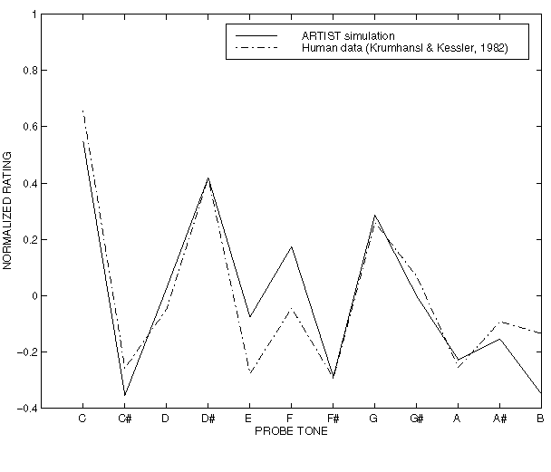

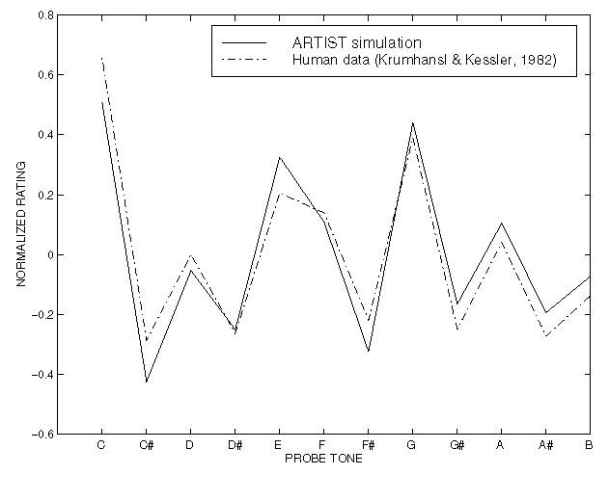
Figure 1: Comparison of tone profiles from human data and ARTIST’s, for major (left) and minor (right) modes.

We can recognise on this plot a 3-D extension of the 2-D plots of the tone profiles in Figure 1. In the latter, the highest peaks in decreasing order are for pitches C (the tonic), G (the fifth), E (the major third), F (the fourth), and so on… The peaks are in the same order in the plot of synaptic weights as we move from the foreground to the background, to end with the 5 peaks corresponding to the 5 chromatic pitches of the C major scale.
The fact that the visualisation of the connexions can be organised in such a way to enable understanding of how the model works has strong implications. This enables us to manipulate it easily and to use it to develop applications. For instance this can guide us to find a way to code the music in symbolic terms related to tonality, independently from the surface details. This code can relate to key modulations, the evolution of tonal tension within the piece, mode changes, resolutions, etc… In other words, anything relating to the tonal features themselves.
Figure 2: ARTIST’s “synaptic landscape”.
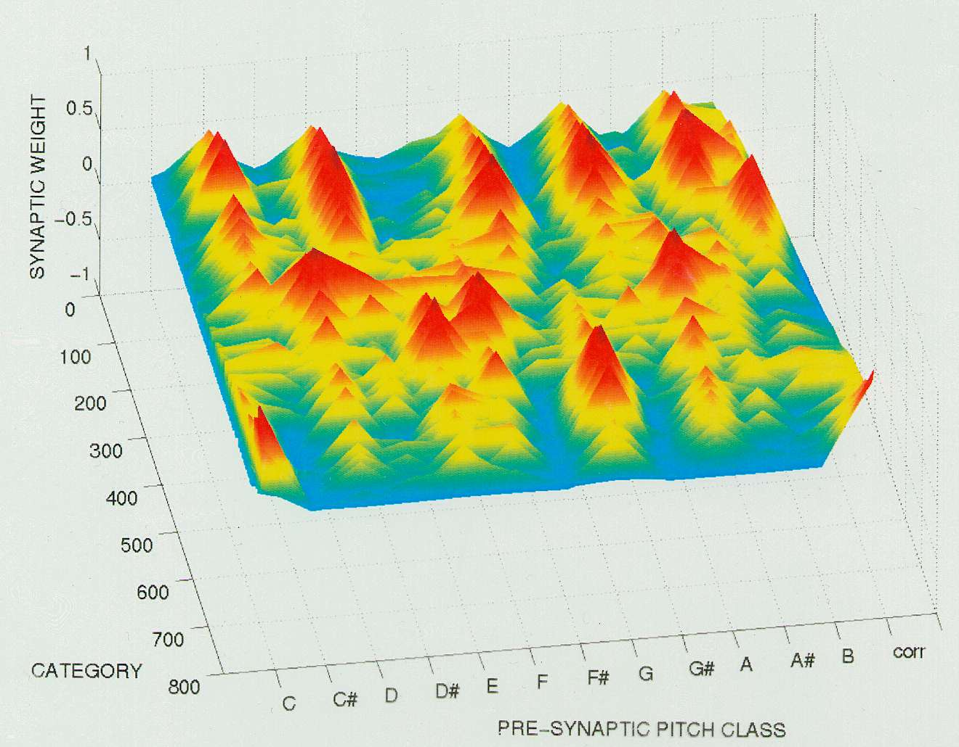
More precisely, this code can be seen as a mapping of the inputs, the music, onto the F2 categories or their corresponding connexions. Once we know how to map the unfolding music onto this “synaptic landscape”, observing the path described by the music can tell us right away many things about the music: coherent music moves smoothly from one peak to a neighbouring peak, whereas when the path goes back and forth between the foreground and background it means the modulations are in distant keys and the music is perceived as incoherent. We can immediately see the subtleness of the modulations, whether they go to close or distant keys, as well as their directions, the frequency of return to the original key, and so on…By mapping several songs onto the same landscape, we can compute their similarity or look for specific features they have in common. Note that all the above is relative to the musical experience of the model, which is under total control of the user. Another possibility would be to compare directly the 2 landscapes generated by 2 songs or sets of songs. However, unlike the first approach mentioned above, this method would probably lose a lot of the temporal information which might be crucial to the particular feeling generated by a piece.

POTENTIAL APPLICATIONS TO THE WWW

Music Search
In any case, having a symbolic-based measure of similarity between songs, or of conformity of a song to a certain profile (synaptic landscape), opens many options regarding music search engines. It enables us to compute to which degree a song fits the criteria specified by the user, which can be defined in many different ways. This is where a WWW-based implementation would offer its greatest advantage, by providing access to extensive databases of songs. For instance, the musical inputs used to generate the profile after learning can be:
- All the songs the user has been listening to lately,
- A subset of these, hand-picked by the user or for which he has given feed-back that he likes, with the possibility to restrict to small passages,
- A set of songs chosen by the user, explicitely or implicitely by a choice of characteristics or labels that can be as different as “Classical”, “Classic Rock”, “Sad”, “Relaxed”, “dissonant”, “atonal”, “modal”, “polytonal”, “Beatles-like”, “with rapid changes of mood”, etc…
For the latter option, it is necessary to pre-define the correspondance between a label and a list of songs representative of its characteristic. The user can choose any number of labels and even give them different weights according to the importance he wants to give to a certain characteristic vs another. When several labels are chosen simultaneously, the song lists are merged to constitute the musical corpus used for learning. Giving them weights affects the number of times the song is presented to the NN for learning. The generalisation capacity of NN means that we do not need a music specialist to rate all the songs on all the criteria. Just like the 24 Bach Preludes were sufficient to retrieve and internalise the rules of tonality, making a list of a few songs to learn should be sufficient for the model to build a prototypical knowledge of their common quality. However, in order to learn to recognize a new quality, the song list has to be representative of it.

Composition and Improvisation
Another straightforward way to exploit ARTIST’s sense of aesthetics is to make it create music, since it is supposed to know exactly how good a note will sound after a given context. To get such a prediction, we have to use the same procedure as for the probe-tone technique: play the note we want to test, then measure the overall F2 activation. The lower the activation, the better the note fits in the context. We can repeat this operation for all the notes in order to obtain an array of activations. Then, depending on the task we want the model to perform, we can use this array in different ways. As a tool for assisted composition, it can list the notes, chords and/or harmonisations in a decreasing order of goodness. As a generator of alternative versions around a main theme, we can set parameters to indicate how close to the original theme we want the new version to be, that will determine the proportion of notes substituted, and how far can the substitutions go in terms of tonality. At one extreme, the original theme would remain unchanged, whereas at the other extreme it would be random. In between are the versions more or less recognisable, just like when some good Jazzman teases the audience with a piece that sounds familiar but that we cannot identify until he gets close enough to the original theme. The same method can be used for an interactive improvisation system, as it is often the case with musicians that interactive improvisation starts from a common theme and evolves from there, or that the ‘duel’ is based on repeating the partner’s phrase with added embellishments or variations, tonal, rythmic or otherwise.
For all these possible uses mentioned, the output of the model can be constrained to fit a particular scale or chord progression (or to be more likely to fit it, by using a kind of transfer function shaped as the corresponding tone-profile), which can be useful when the model is used as a help for teaching or rehearsing. But the most important for a successful musical creation is probably the strategy used to choose the note(s) from the array of activation, that is, to transform these activations into an array of probabilities (It is possible to make the system deterministic, but that is certainly the best recipe to create the most boring composer). The computations used for Boltzmann machines, the normalisation used in Hidden Markov Models or the Gibbs-Sampler algorithm, to name a few, will probably yield interesting and inspired automatic compositions.

conclusion
We have shown that after being exposed to a few pieces of music and deriving prototypes from them through learning, the NN ARTIST develops a structure that captures the rules of tonality. Based on this, it is able to predict with a very good precision the human judgements of the aesthetic of a short musical sequence. This judgement is solely based on ARTIST’s experience with music. Since the user has complete control over its musical universe, ARTIST can be used to extract prototypes from his favorite music. From this customised profile, ARTIST should be able to find the songs that the user will like best, or even compose some songs. Furthermore, this can be done independently from the usual musical styles classification, because what has been learnt essentially relates to the deeper musical properties linked to tonality and transcends the surface details. However, before such applications are operational, more research is needed to be sure that ARTIST can go from the small-scale problems it has been shown to solve, to the full size problems evoked above. In particular, it remains to be seen whether it will work as well with complete music pieces as it does with 10-notes sequences. Also, it is possible that feeding radically different musical styles to the NN for learning may produce unexpected results because of some interference. But there seems no reason for this to happen as long as all is tonal music, and we have good hope that ARTIST would yield meaningful results even in the case of atonal or polytonal music. However, simulations need to be done to know if the internalisation of these different musical styles can be merged into a single model or if several models need to run in parallel and merge their results. Finally, the model will need some optimisation before it can be used for the WWW, to minimise all computations. The optimal vigilance/number of categories will certainly depend on the task to be achieved. But there are good reasons to hope that one day each of us can have his own custom radio that only plays what we like.
REFERENCES
- Bharucha, J.J. Music cognition and perceptual facilitation: A connectionist framework. Music Perception 5 ,1 (1987), 1-30.
- Carpenter, G.A., & Grossberg S. ART2: Self-organization of stable category recognition codes for analog input patterns. Applied optics 26, (1987), 4919-4930.
- Krumhansl, C.L. The cognitive foundations of musical pitch. (1990). Oxford psychology series, No. 17.
- Krumhansl, C.L., & Kessler, E.J. Tracing the dynamic changes in perceived tonal organization in a spatial representation of musical keys. Psychological Review 89, (1982), 334-368.
- Krumhansl, C., & Shepard, R. Quantification of the hierarchy of tonal functions within a diatonic context. Journal of Experimental Psychology: Human Perception and Performance 5, (1979), 579-594.
- Piat, F. ARTIST: Adaptive Resonance Theory for the Internalization of the Structure of Tonality (a neural net listening to music). Doctoral dissertation. http://www.image.ntua.gr/~piat
- Piat, F. ARTIST: A connectionist model of musical acculturation. In Proc. 6th International Conference on Music Perception and Cognition (ICMPC), (August 5-10, 2000), Keele University, UK. http://manolito.image.ece.ntua.gr/~piat/papers/ARTIST/Artist.html

